**Free Gift Extension for Magento 2**

Magento Free Gift extensions helps encourage more sales by offering free gifts to customers.

Using the Magento Free Gift extension will allow you to automatically give free products to your customers based on their product or service purchases.

## **Why Do You Need An Order Reminder?**

**Magento Free Gift extensions** helps encourage more sales by offering free gifts to customers. Free gifts are a very powerful motivator when making sales. In fact, it has been shown that giving something for free can encourage more sales than just giving a discount - even if the discount is more than the value of the free gift. Nothing is more powerful than the word free!

## 

## 

## 

## 

## 

## 

## **Installation**

**Interested in Extension Installation ?**

Visite our installation service page <https://www.extendware.com/magento-extension-installation-service.html> for more information

Got questions? Feel free to contact us! [Support Form](https://support.extendware.com/).

**Installation procedure**

1. Download your extension package from the [Download](https://www.extendware.com/downloadable/customer/products/) page after purchasing the extension.
2. Open the extension ZIP file you downloaded and extract it to a directory on your computer using a tool like WinRar, WinZIP or similar.
3. Upload the extracted folders and files into the root directory of your Magento installation. The root directory of Magento is the folder that contains the directories "app", "bin", "lib" and more. All folders should match the existing folder structure. If one of our extensions is already installed and you're updating it, make sure to overwrite the existing files of the extension.
4. Connect via SSH and run the following commands (make sure to run them as the user who owns the Magento files!
5. php bin/magento module:enable --clear-static-content Extendware_Core
6. php bin/magento module:enable --clear-static-content Extendware_FreeGift
7. php bin/magento maintenance:enable
8. php bin/magento setup:upgrade
9. php bin/magento setup:di:compile
10. php bin/magento setup:static-content:deploy
11. php bin/magento maintenance:disable
12. In case if you still do not see the extension active, Go to Admin -> System -> Cache Management and click both the 'Flush Magento Cache' as well as the 'Flush Cache Storage' button.
13. Woo-ha! You have successfully installed the extension and your store is ready to protect from spammers and bad bots.

## **USER GUIDE**

**You will find all extendware settings in Admin Panel → Extendware Menu**

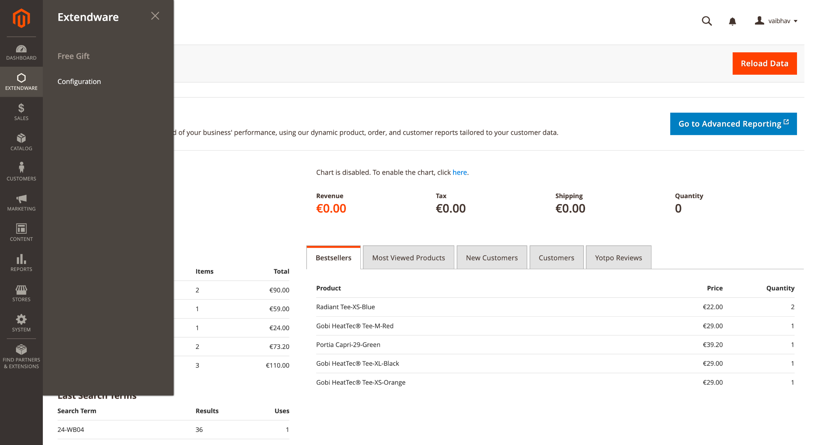

**To configure the extension you need to go to Admin Panel → Extendware Menu → Extendware Free Gift → Configuration.**

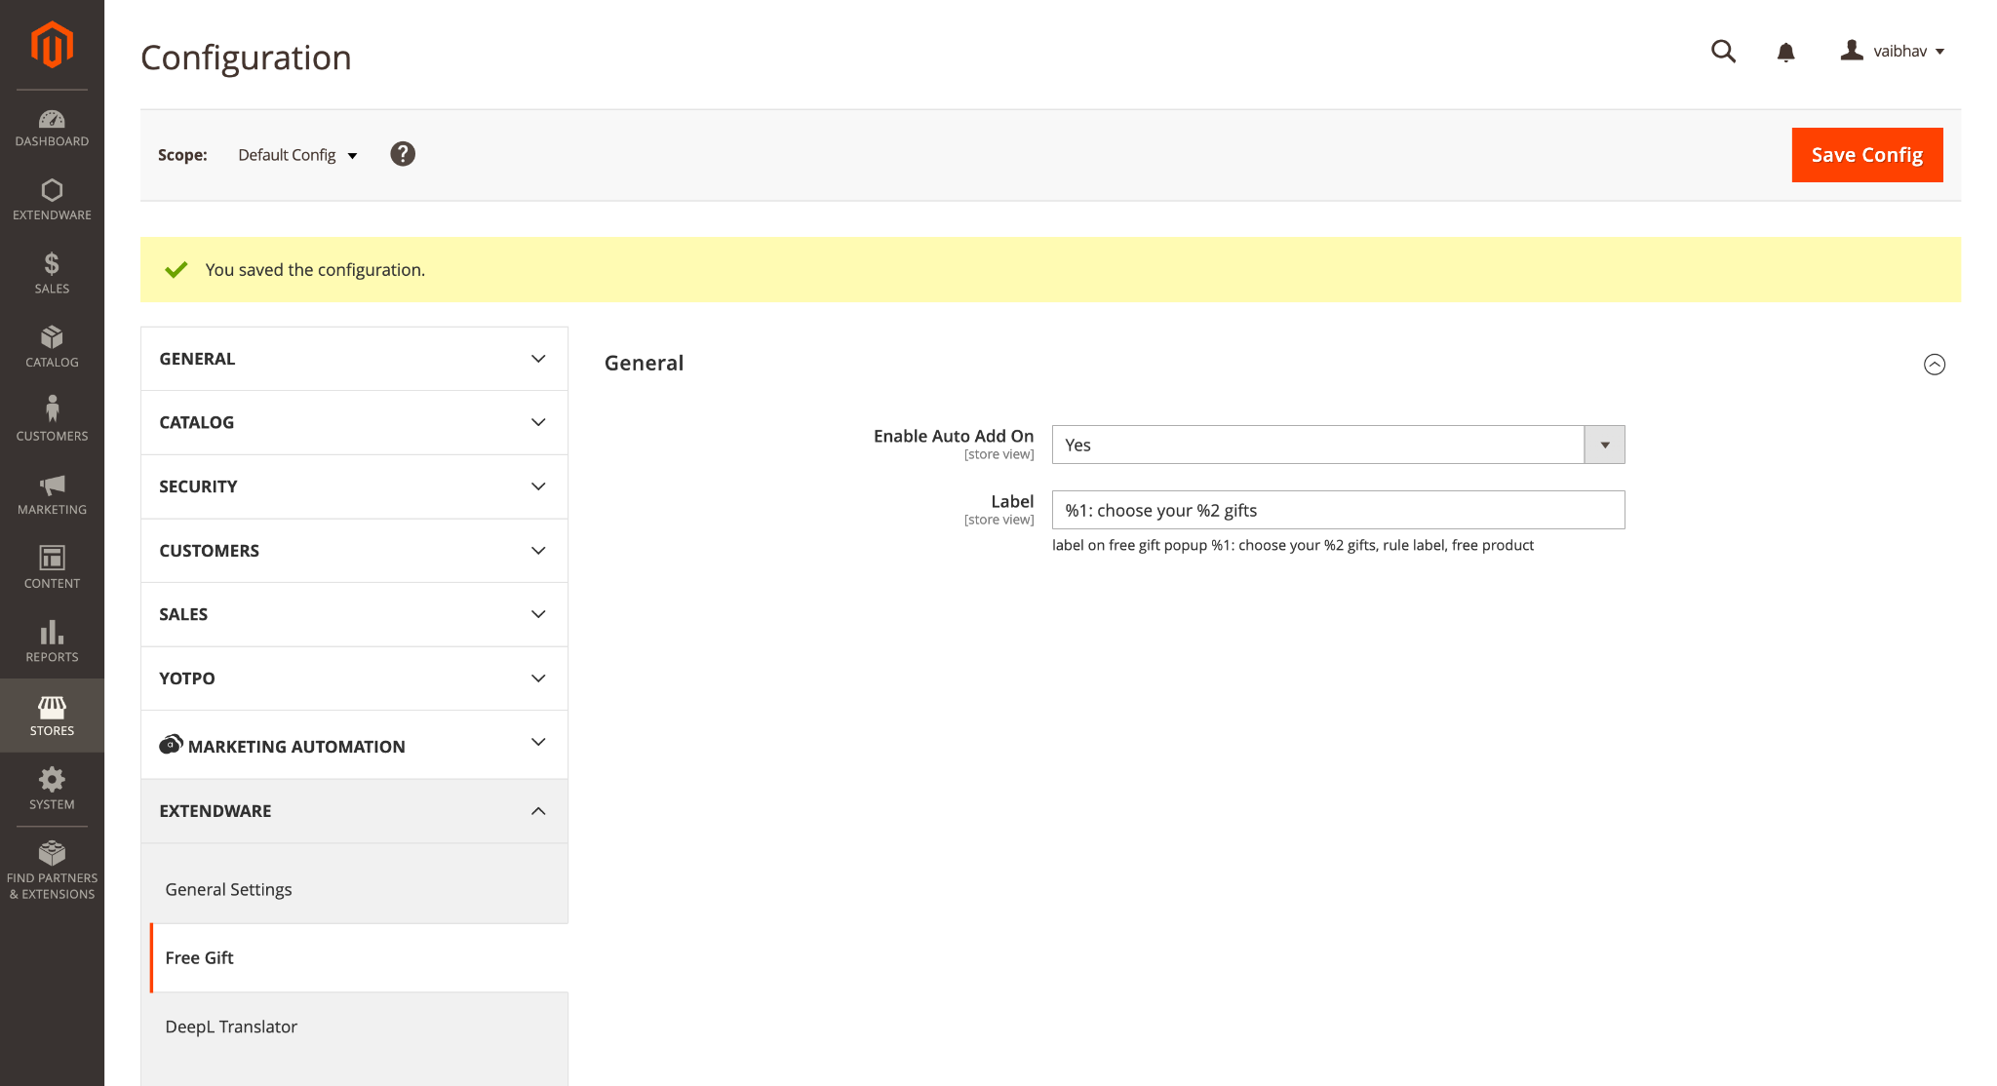

**Free gift General Configuration**

**Enable Auto Add On** - If Yes then free gift products will be added automatically when customers add regular products to cart.

**Label** - Admin can customize label messages from here, which will be displayed on cart page free gift popup.

**Admin can create free gift rules from magento cart rules From Admin Panel → Marketing → Cart Price Rules** 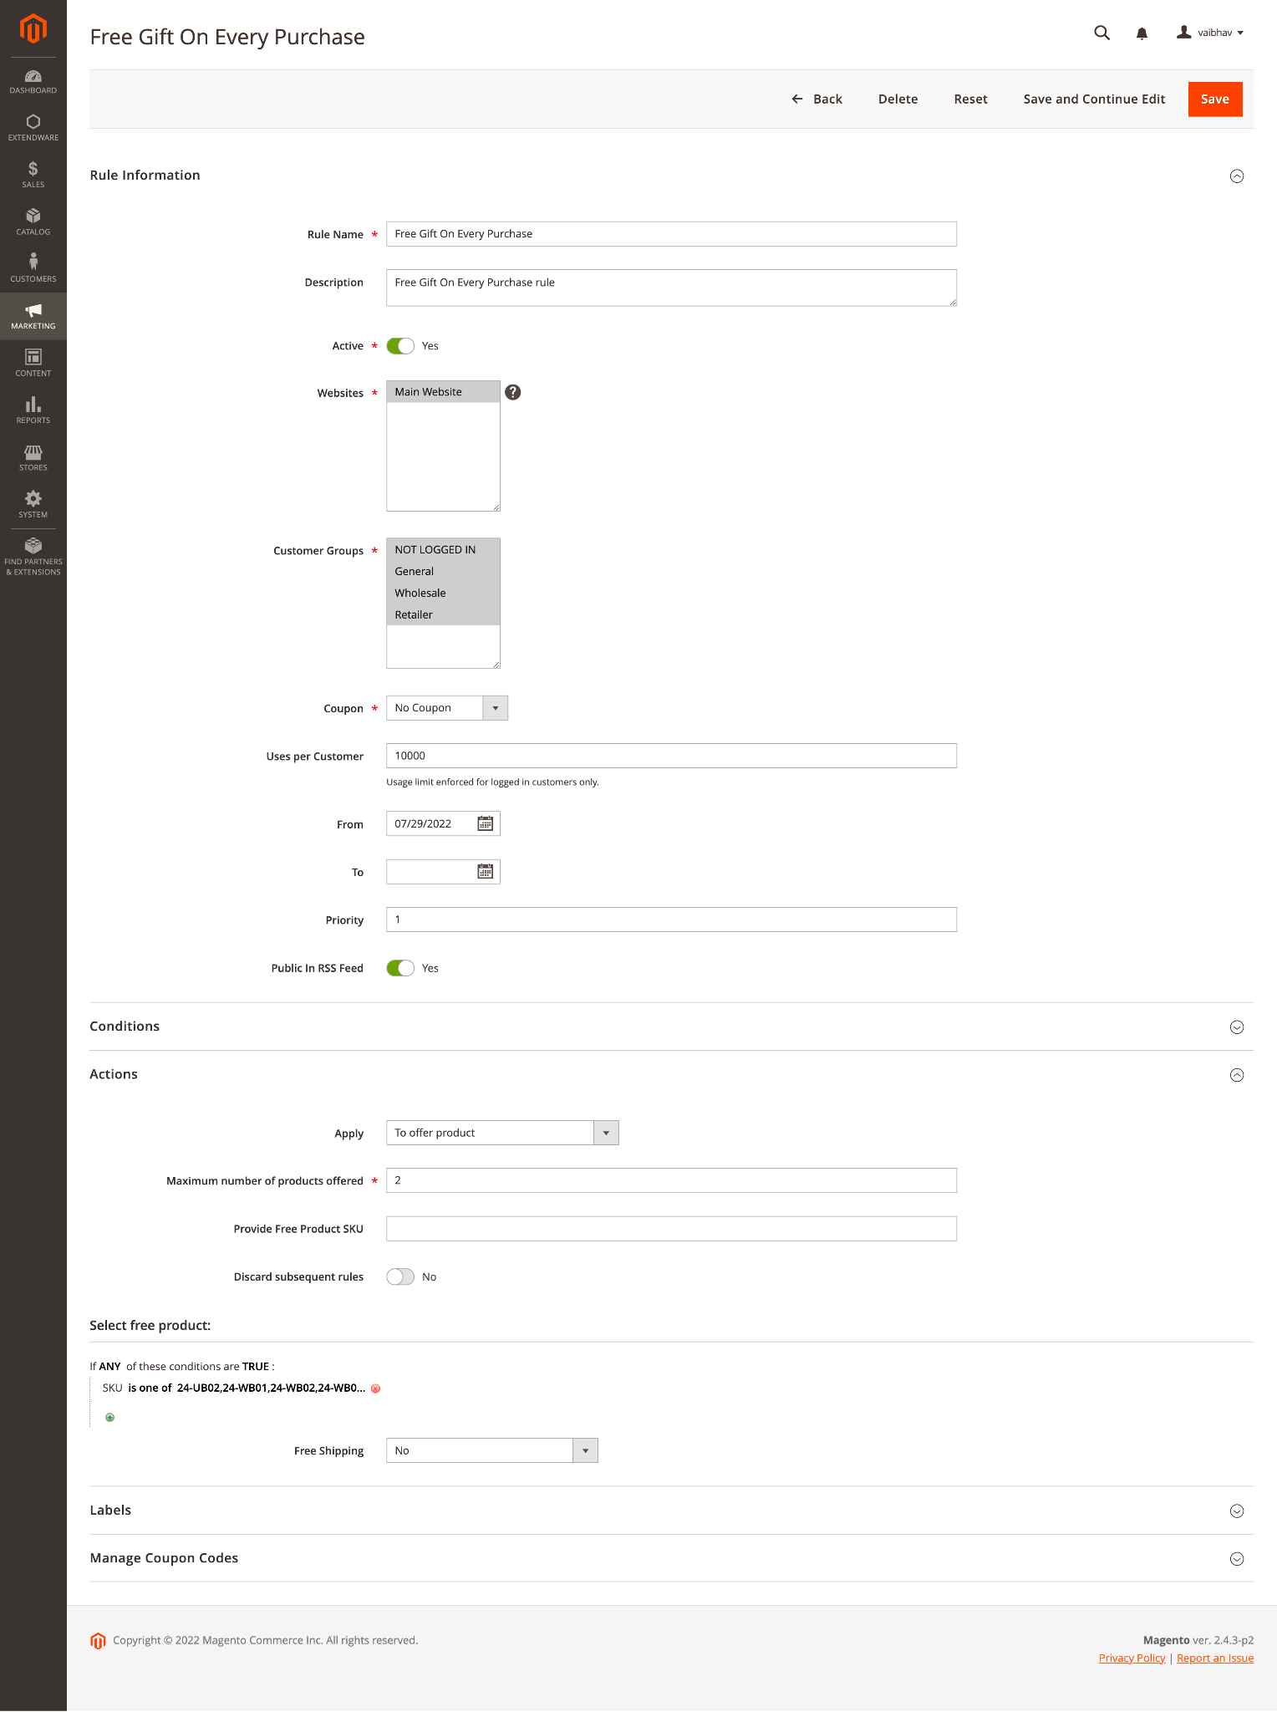

Admin will have the option to select either if they want to give a gift product for all conditions or only if the customer purchases more then specific price. Admin can select either 1) To offer product or 2) To offer product per price range

Admin will option to select which gift product they want to give to the customer, if there is only one product then admin can add sku into **Provide Free Product SKU** or admin can select multiple products based on condition from Select free product  
Here admin can add multiple SKU or product attribute base conditions to define free gift products. These products will be displayed on the cart page as a popup and customers select the product that they wanted for free.  
  
**On the frontend when a customer adds a product to card based on cart product free gift rule is activated and it will add free gift product to cart automatically.**

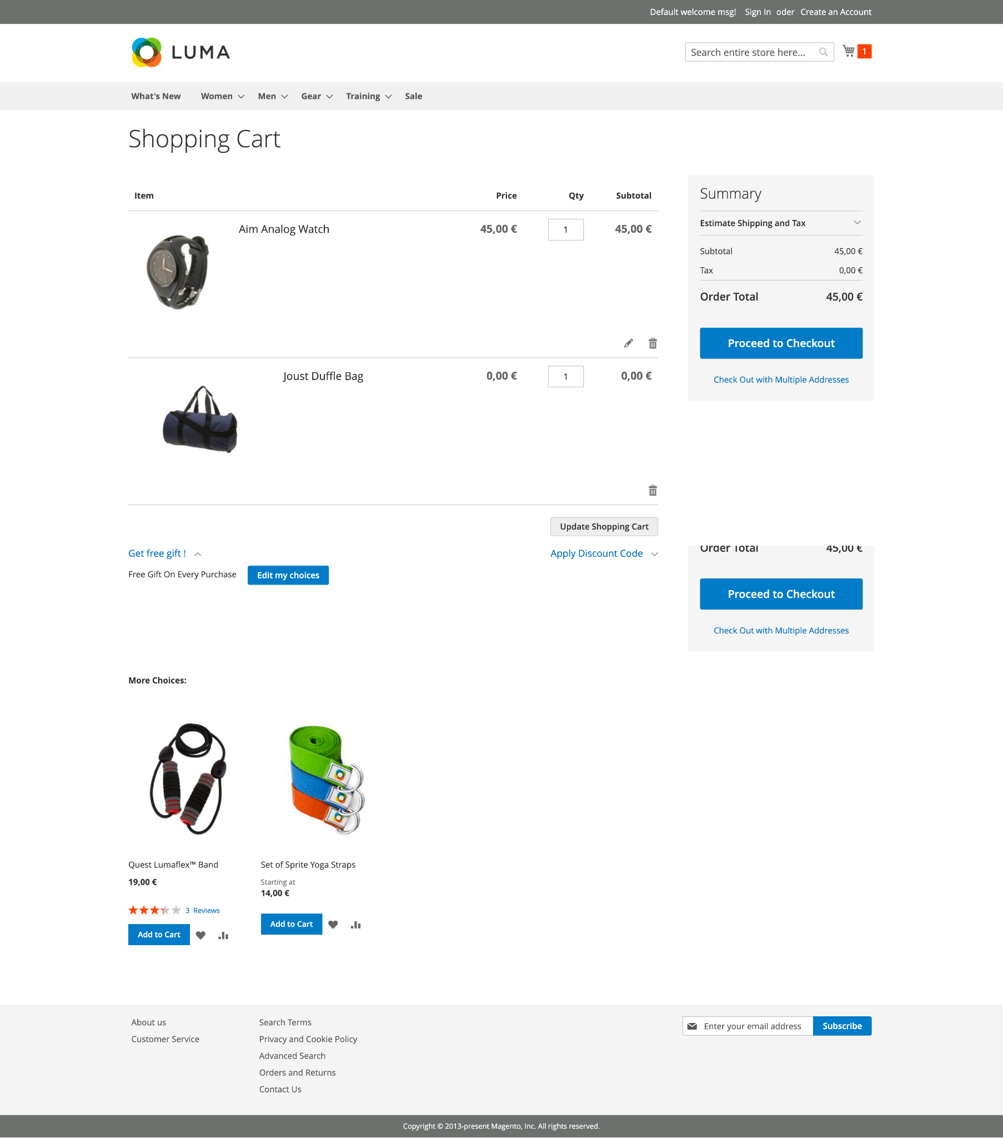

On the frontend customer will have the option to select a free gift option. They can check the available free gift product list from the **Get free gift** button. When a customer clicks on the Get free gift button it will display the applied rule and Edit my choices button from where customer can select free gift products.

**On the free gift popup customer can see message which were configured in the admin and list of available products.**

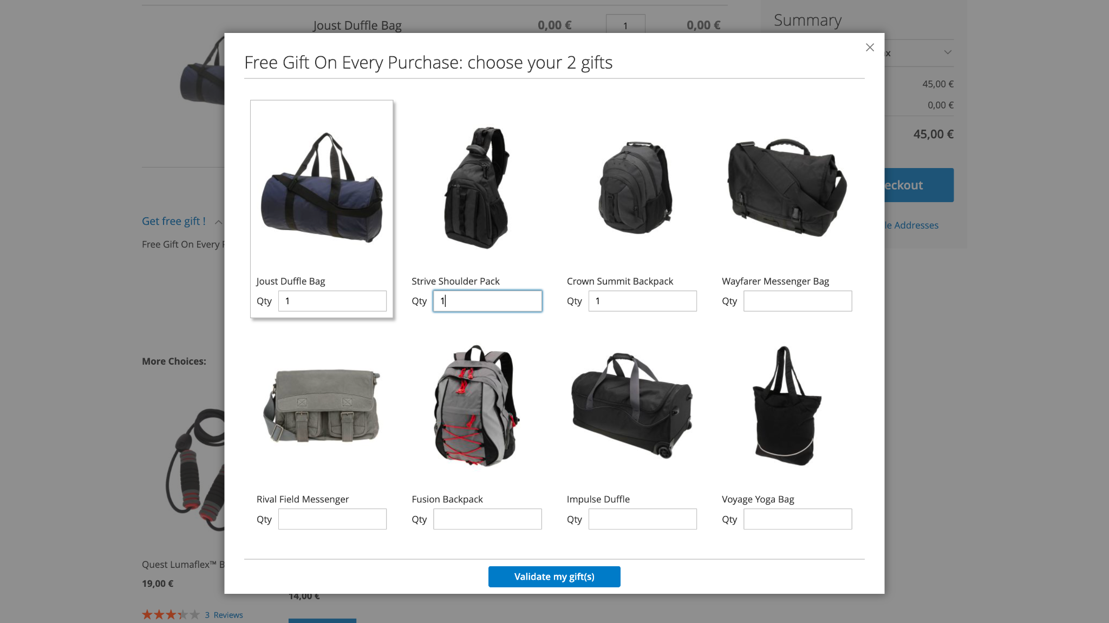

Customers can select products from the above popup for free and click on the validate button. The system will validate rules and product add free gifts to cart.